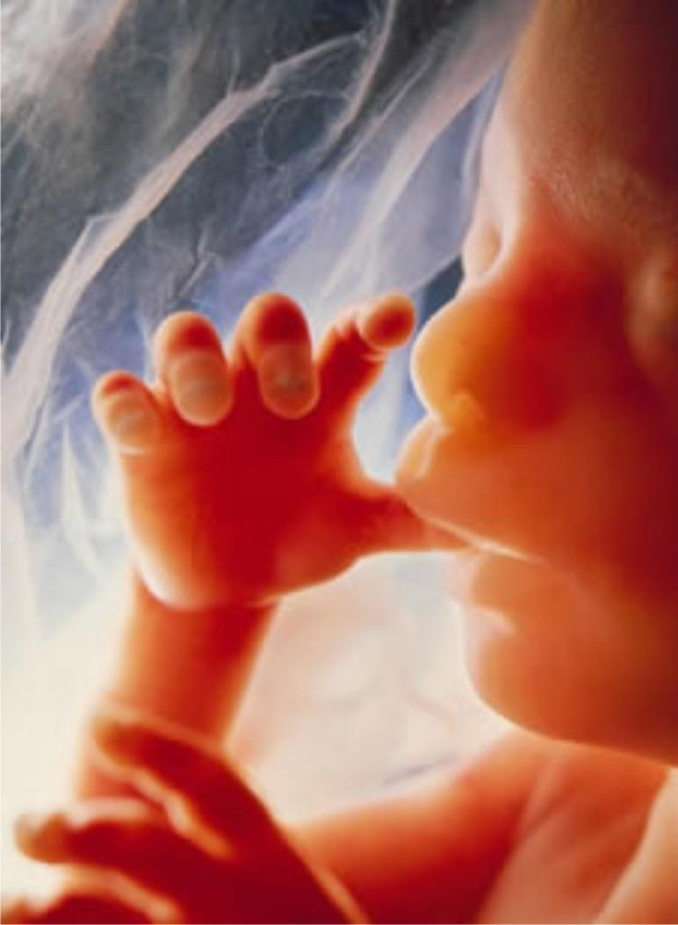

Minnesota Youth For Life

no exceptions conference

When: January 19, 2015: 10am-4pm

Where: St. Raphaels Catholic Church– crystal, MN

Who: Anyone 13 years or older

Cost: $10 - includes all talks an d lunch

Register at: www.SH-R.com/Prolife

Ever heard it said I am pro-life Except in cases of

*rape, incest, health of the mother, or the baby will have some disability?*

This conference will provide you with the answers–

**from first hand survivors**

Speakers include

Bishop Andrew Cozzens - Survivor

Rebecca Kiessling - Survivor

Kristi Hofferber - Survivor

MN House Rep Nick Zerwas -Survivor