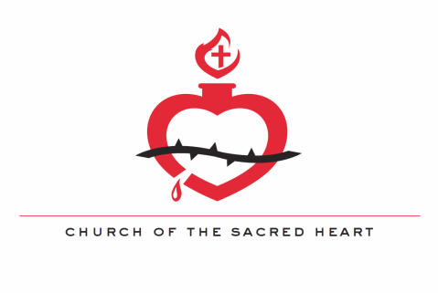

Dear Sacred Heart Families,

My name is Matt Kruc and I am the Confirmation Coordinator for Sacred Heart. If you are receiving this letter, then your son or daughter is about to begin preparation for receiving the Sacrament of Confirmation. The first year of this process focuses primarily on weekly catechetical preparation classes, working out of the Catechism of the Catholic Church as well as the Gospels.
- Attend weekly confirmation preparatory classes three Wednesday nights and the monthly High School Youth Night or Lifeline Mass. Teens will not need to come to Wednesday night class when there is a Saturday event. The schedule for the first semester is as follows:
-Wednesday, November 16th- No Wednesday Class Saturday, November 19th- Senior High Night
-Wednesday, December 14th – No Wednesday Class Saturday, December 17th – Senior High Night
-Wednesday, January 18th – No Wednesday Class Saturday, January 21st – Senior High Night
*Please note that October is not included as the first Youth Night is also the week of the first class. Regular class attendance is expected for October*
- Complete 10 hours of community service, 5 of which must be in connected to Sacred Heart Church or School.
- Attend either the Archdiocesan Youth Day on October 29th and/or the Spring Confirmation retreat (Date TBD).
- Regular participation in the sacrament of Reconciliation.
- Weekly Sunday Mass attendance.
  - Since Sunday Mass is essential to a life of faith, we will be requiring confirmation students to attend the 10:00 AM mass each Sunday at Sacred Heart, barring a legitimate excuse (singing or alter serving at a different mass, attending a different mass with your family, sick, etc.). Sacred Heart youth will also be attending Lifeline Masses the first Saturday of every month, so this is also an option for mass attendance.
I highly encourage getting involved with the youth ministry activities around Sacred Heart. They are an excellent opportunity to grow in faith and fellowship. Check the Youth Ministry section of Sacred Heart’s website for more information. Please contact me with any questions at mkruc@shrmn.org and I’ll respond as soon as I am able.
God Bless,
Matt Kruc
Youth and Young Adult Minister

