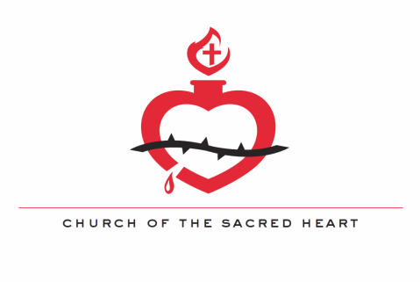

Dear Sacred Heart Families,

My name is Matt Kruc and I am the Director of Confirmation at Sacred Heart. If you are receiving this letter, then your son or daughter is about to begin preparation for receiving the Sacrament of Confirmation. The varies depending on private vs. public school attendance. Those candidates attending a private Catholic school are required to do the following:
- Attend either the monthly High School Youth Night or the monthly Lifeline Mass. Details for both of these should have been received by mail already. If not, please contact me or check the parish website under Youth (www.shrmn.org/youth).
- Complete 10 hours of community service, 5 of which must be in connected to Sacred Heart Church or School.
- Attend either the Archdiocesan Youth Day on October 29th and/or the Spring Confirmation retreat (Date TBD).
- Regular participation in the sacrament of Reconciliation.
- Weekly Sunday Mass attendance.
  - Since Sunday Mass is essential to a life of faith, we will be requiring confirmation students to attend the 10:00 AM mass each Sunday at Sacred Heart, barring a legitimate excuse (singing or alter serving at a different mass, attending a different mass with your family, sick, etc.). Sacred Heart youth will also be attending Lifeline Masses the first Saturday of every month, so this is also an option for mass attendance.
I highly encourage getting involved with all the youth ministry activities around Sacred Heart. They are an excellent opportunity to grow in faith and fellowship. Check the Youth Ministry section of Sacred Heart’s website for more information. Please contact me with any questions at mkruc@shrmn.org and I’ll respond as soon as I am able.

God Bless,
Matt Kruc
Youth and Young Adult Minister

